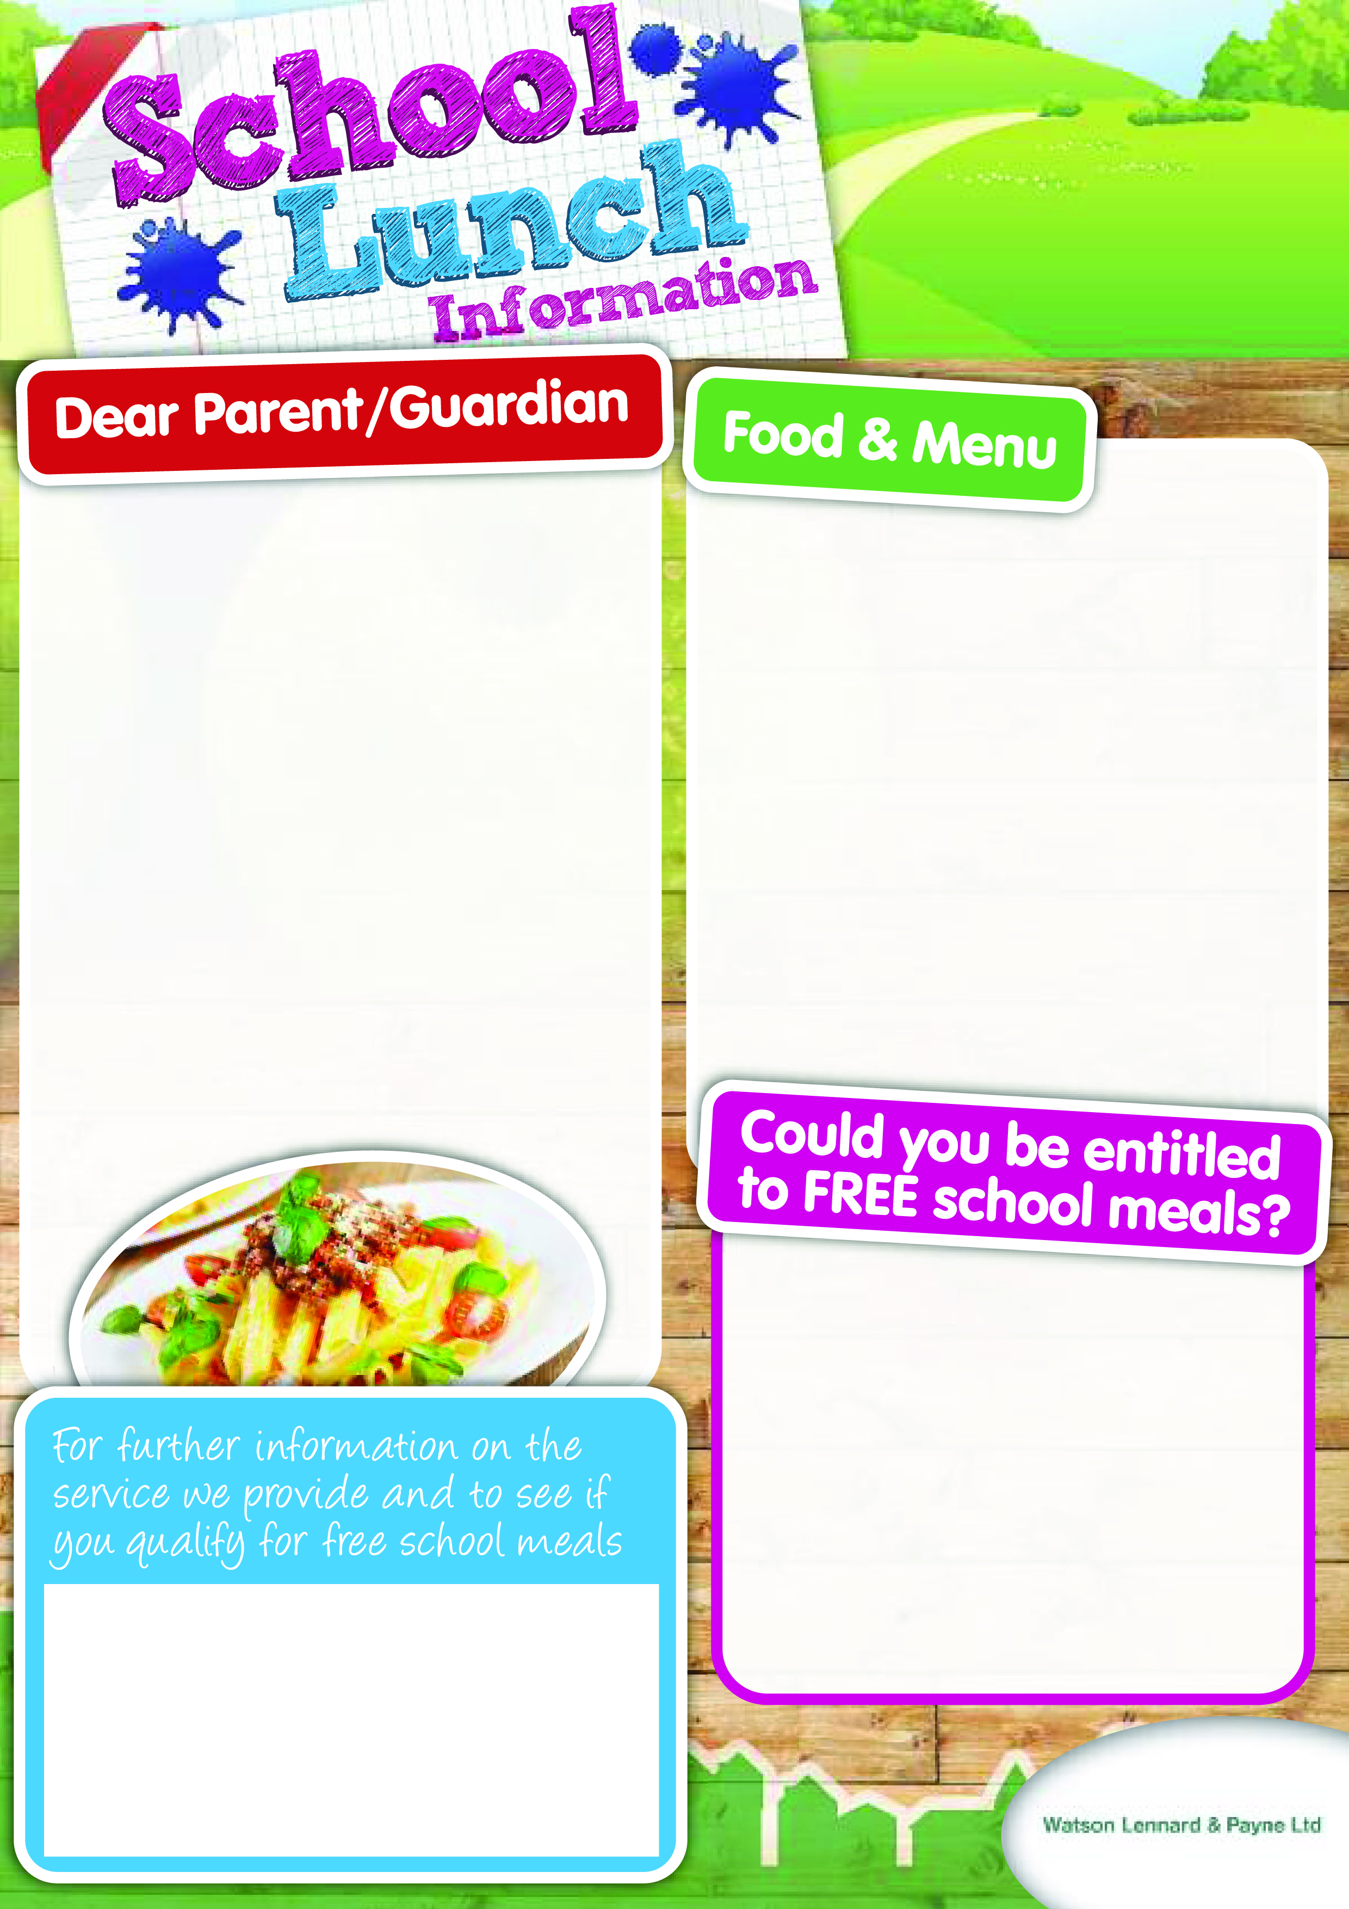

***Hodnet Primary School***

***Lunch Menu***

***January 2016***

*Welcome back to Hodnet Primary School after the holidays! Once again we would like to share with you some of the exciting things that we have planned for the lunch service! Debbie our Cook and her team have put together a new set of menus for the Spring Term, featuring many of the pupils’ favourite dishes along with some new seasonal variations! We would like to build on the success of Universal Infant Free Meals for Key Stage 1 pupils, introduced last September and hope that those pupils moving into Key Sage 3 will continue to support the School’s catering service by purchasing a meal. We believe that this is still excellent value at just £2.10 a day.*

***School Food Based Standards January 2015***

*Our menus are carefully planned to comply with The School Food Based Standards introduced in January 2015. Variety is the key with different fruits, vegetables, whole grains and fresh meat and fish on offer throughout each week. There is an aim to reduce fat in the diet which includes any carbohydrates cooked in oil, pastry items and breaded products. We are able to cater for pupils who may have special dietary needs and Allergen information is available on request.*

*All those children in receipt of Free School Meals are*

*entitled to a drink of milk during the school day– this will be available through our Cool Milk Scheme.*

*We have printed a copy of our new menus on the reverse of this newsletter and we welcome your comments and children’s feedback in the new term.*

If you claim certain benefits or have a household income below the Government threshold, you could qualify for Free Meals it is important that even if your child is entitled to the UIFSM you still complete the application for Free Meals .

Please speak to a member of the school staff or

Visit: www.shropshire.gov.uk/**free**-**school**-**meals**/or call**: 0345 678 9000** for more information

School Office Tel: 01630 685300

Email: admin@hodnet.shropshire.sch.uk

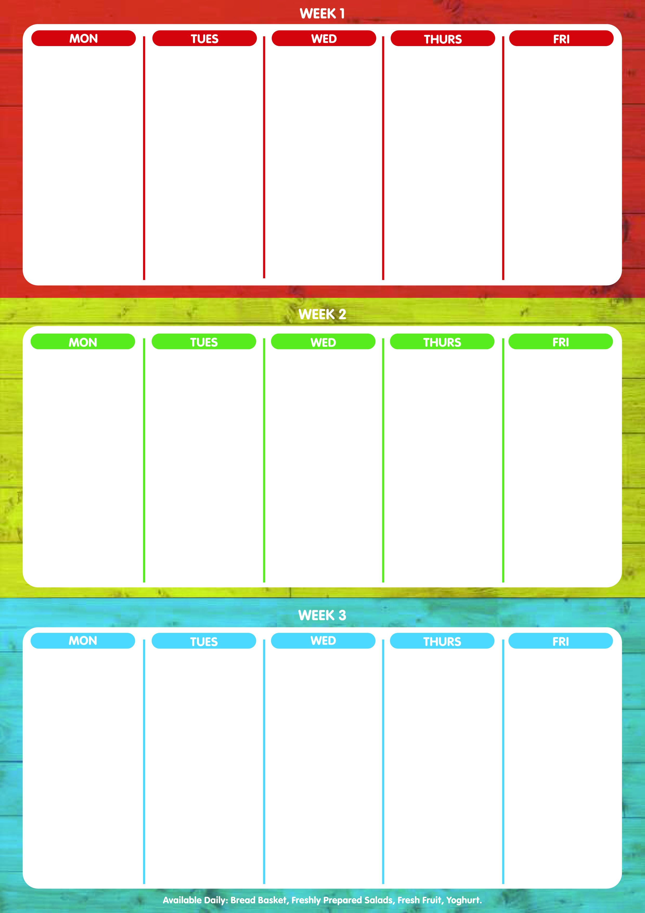

Cheesy Pizza

Vegetable Quiche

******

Chips

Baked Beans

Sweetcorn

Seasonal Salads

******

Homemade

Cookie

Baked Gammon

Pineapple

Roast Quorn Fillet

******

Creamy Mashed Potatoes

Roast Potatoes

Sweetcorn

Broccoli

Seasonal Salads

******

Fruit jelly Pots

+

Cookie

Cottage Pie

Spicy lentil Casserole

Puff pastry cheese parcels

Baked Potato wedges

Carrots

Cauliflower

Seasonal Salads

******

Lemon Sponge

With

Custard

**Week 1 - Week Commencing 4th Jan; 25th Jan; 22nd Feb; 14th Mar; 2016**

Beef Hotpot

Vegetarian Hotpot

Tomato and Herb

Pasta

*******

Crusty Bread

Carrots

Cabbage

Seasonal Salads

******

Chocolate Brownies

+

Cream

Cowboy Casserole

Vegetarian Casserole

Fish Fingers

******

Creamy Mash Potatoes

Peas

Baked beans

Seasonal Salads

******

Rice Pudding

+

Fruit

Shortbread

Week 2 – Week Commencing 11th Jan; 1st Feb; 29th Feb; 21st Mar; 2016

Lasagne

Vegetable Lasagne

Vegetable Frittata

Crusty Bread

Jacket Potatoes

Green Beans

Sweetcorn

Seasonal Salads

******

Lamingtons

Shortbread

Roast Chicken

Roasted Quorn Fillet

******

Roast Potatoes

Creamy Mashed Potatoes

Carrots

Cabbage

Seasonal Salads

******

Raspberry Mousse

Chicken and Veg Pie

With a Potato Crust

Vegetarian pie

Fish Cakes

*******

Creamy Mash potato

Broccoli

Carrots

Seasonal Salads

******

Chocolate and Orange

Sponge

With

Chocolate sauce

Spaghetti Bolognaise

Vegetarian Bolognaise

Salmon Fillet

*****

Garlic Bread

Boiled Potatoes

Peas

Sweetcorn

Seasonal Salads

******

Fruity Flapjacks

Meat-free Fridays:

Cheesy Pizza

Sea Dogs

******

Chips

Herby Pasta

Peas

Baked Beans

Seasonal Salads

******

Apple Bakewell Slice

**Week 3- Week Commencing 18th Jan; 8th Feb; 7th Mar 2016**

Chicken Enchiladas

Vegetable Bake

******

Jacket Potatoes

Pasta

Sweetcorn

Broccoli

Seasonal Salads

******

Syrup sponge

With

Custard

Meatballs

Vegetarian Balls

With onion Gravy

******

Cream Mash Potato

Pasta

Carrots

Peas

Seasonal Salads

******

Fruit Crumble

Custard

Flapjacks

Chicken Curry

Dhal curry

Cheesy Pasta

Naan Bread

Rice

Green beans

Cauliflower

Seasonal Salads

Frozen Yogurts

With

Cookie

Meat-free Fridays:

Cheesy Pizza

Ratatouille pasta

******

Chips

Pasta

Baked Beans

Peas

Seasonal Salads

******

Hodnet Biscuit

With a

Glass of Milk

Boeuf Bourguignon

Quorn bourguignon

Yorkshire puddings

******

Boiled Potatoes

Roast Potatoes

Carrots

Roast parsnips

Seasonal Salads

******

Fruit Muffins

**Available Daily: Bread Basket, Freshly Prepared Salads, Fresh Fruit & Yoghurts**